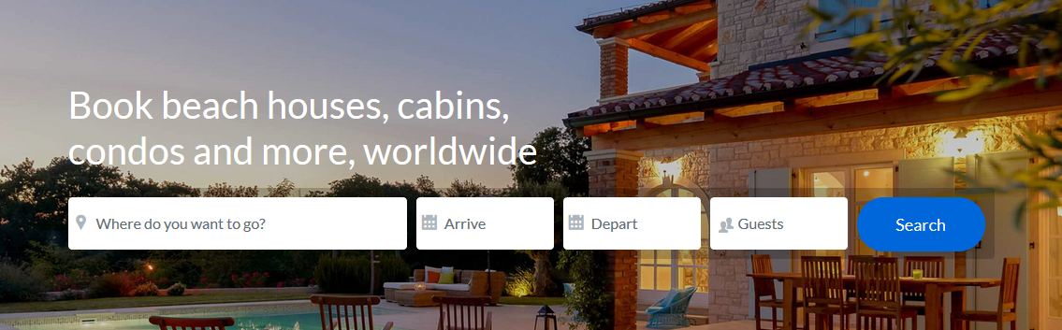

First of all you have to search ‘where you want to go’ then search ‘arrive’ then ‘depart’ then ‘guest’ then press on search button then show you,

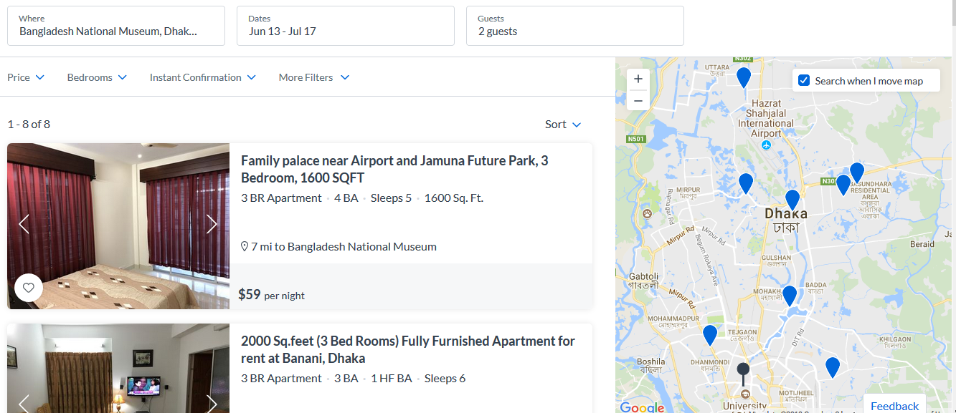

After that you show many apartment here also show you location of specific apartment, design of bedroom and rent cost per night. If you select any apartment then show 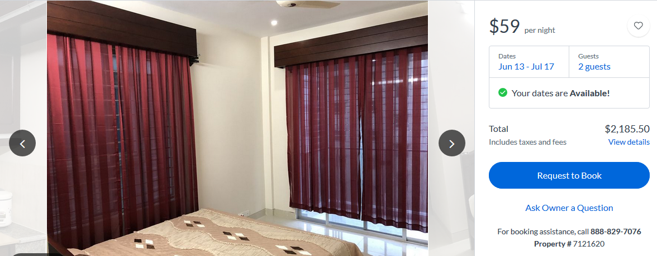

After select any apartment then you have to request for book and show you your arrive and depart time and also show the cost. After that you show the booking system.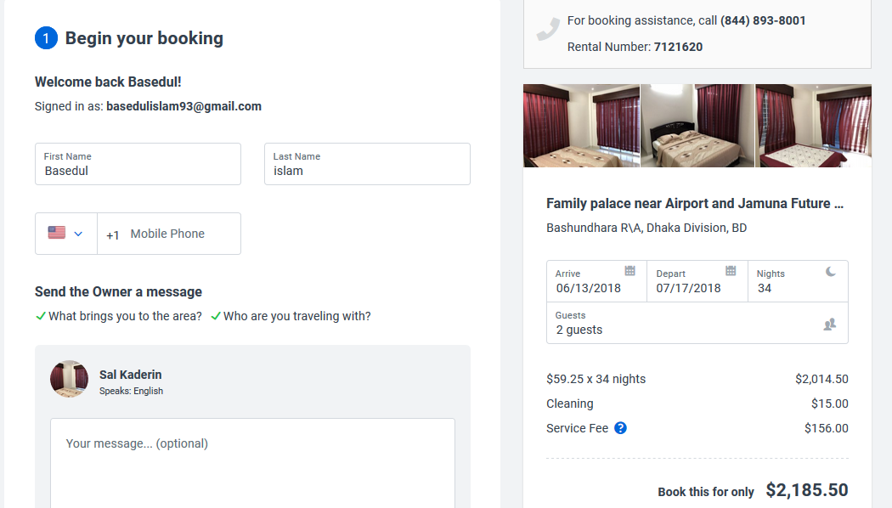

In booking system firstly you should be signup and login, then you give your first name and last name also give your contact number. You see your total cost for hole day. After confirmation you have to pay in advance via payable system. After paying to give you a confirmation message.